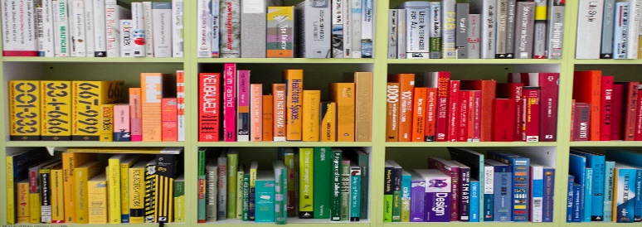
This Photo by Unknown Author is licensed under CC BY-SA
Friends of the CVW Long Lake Public Library
Student Scholarship
The Friends of the CVW Long Lake Public Library Student Scholarship program assists deserving students in realizing their educational dreams. The Friends anticipate awarding 2 scholarships of $500 each to students who will attend an accredited two-or four-year college or university, or a trade/technical school. This scholarship is available to students attending or homeschooled in the Long Lake and Newcomb school districts. Students must be entering their first year of post high school study.
Part I – Student Information
__________________________________________________________________________ Last Name First Name M.I.
__________________________________________________________________________ Street (Permanent Address)
__________________________________________________________________________City State Zip
__________________________________________________________________________
Phone Number Email Address

Part II – Academics

Name of High School You Attend ______________________________________________________ If you are not a LLCS/NCS student, do you live within the library tax district? Yes No
Expected Date of Graduation ________/________/________
Provide a copy of the accredited college/university, technical/trade school you anticipate attending in the fall.

Part III– Resume
Please provide a resume that includes the following from your high school years only: awards/honors, extra-curricular activities, community/volunteer work, and employment. Please do NOT include a transcript.

Part IV Library Connection
Compose an essay that explains how libraries, or a certain librarian have helped to shape who you are OR name a book/author and discuss how it has made an impact on your life. (150-250 words)
(As you design your essay, keep in mind to incorporate personal examples, and proofread prior to submission to catch grammar and spelling mistakes.)
Part IV – Recommendation
Please provide one letter of recommendation from someone other than a family member, who has known you for a significant period of time and who can comment on your character and abilities.
Applicant Signature
__________________________________________________________________________Signature/ Date

The application form and all attachments must be received at the CVW Long Lake Public Library no later than June 1st Applications MAY NOT be faxed or emailed. Application packages that are incomplete or received after the deadline will not be reviewed.

Submit application packets to: Friends of the CVW Long Lake Public Library
Community Scholarship
1195 Main Street
Long Lake, New York 12847

Questions: Please contact Camille Cristaldi, Friends of The Library, at camcris518@aol.com
Award recipients will be notified by the CVW Friends of the Library.
Awards are for one year and are non-renewable.

